CPSC 4317: Computer Networks
Assignment 2
Due: 10:00am Sept. 20, 2024 (Friday)

Name: __Andrew Kalathra___

LUID: ______L20498001______

Date: ______09/20/24________

20 points for the last question (P. 150 -> 8.15). 10 points each for all other questions. Total 100 points.

1. Using “dig” command, please obtain ALL the IP addresses of google.com and cnn.com? (10 points)

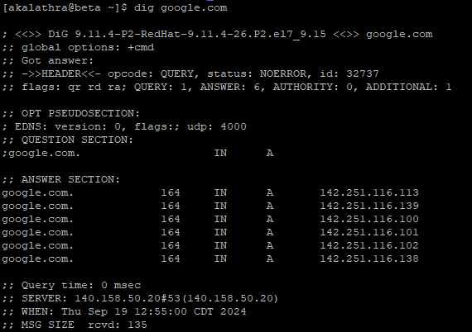

- The IP addresses for google.com are as follows:
142.251.116.113
142.251.116.139
142.251.116.100
142.251.116.101
142.251.116.102
142.251.116.138

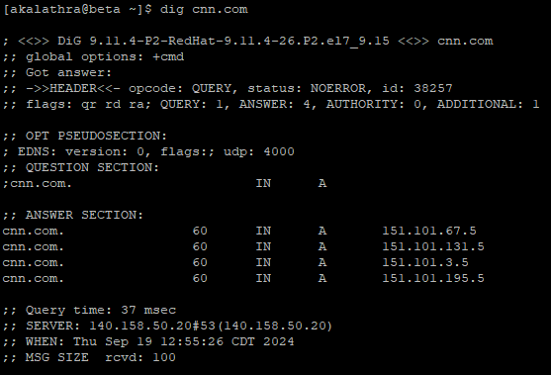

- The IP addresses for cnn.com are as follows:
151.101.67.5
151.101.131.5
151.101.3.5
151.101.195.5

2. What are the differences between Control Connection and Data Connection in FTP? (10 points)

- FTP is a file transfer protocol. In this protocol, clients interact with servers to transfer data (typically from the server to the client).
- Two connections are formed, one for the client to request resources, and the other to transmit the resources.
- The Control Connection is created by the client. The client requests resources over this connection to the server. This connection is long lived and expires when the client chooses to disconnect from the server.
- The Data Connection is created by the server. When a request is received from the client, the server creates this connection, transmits the requested files (or directory, in general data), and then closes the connection. In this way, the Data Connection is short-lived is created every time data needs to be transmitted from the server.

Textbook: P. 111 -> 6.14 What is the bandwidth of a digital signal? Explain.
- An analog bandwidth is described as the difference between the highest and lowest frequency.
- Since digital signals do not have frequencies, but rather have voltages, this definition cannot be carried over.
- If applying Fourier analysis, we will realize that there will be a production of infinite sine waves with frequencies that go to infinity. In the definition was carried over, then this would mean that digital signals have infinite bandwidth.
- That is why there is not much use of bandwidth with digital signals.

6.20 If the maximum frequency audible to a human ear is 20,000Hz, at what rate must the analog signal from a microphone be sampled when converting it to digital?

- As given by Nyquist’s theorem, we can get the sampling rate using his formula:
- Sampling rate = 2 * f_{max}
- Sampling rate = 2 * 20,000 Hz
- Sampling rate = 40,000 Hz

Textbook: P. 132 -> 7.21 What is the relationship between bandwidth, signal levels, and data rates?
- As given by Shannon’s Theorem (or Nyquist’s), we can use the formula to describe the relationship
  - C = B log₂(1 + S/N)
  - C is the effective limit on the channel capacity in bits per second, which can also be interpreted as the data rate
  - B is the bandwidth
  - S is the signal power or signal level
  - N is the noise power or noise level
  - Using Nyquist’s will define the same relation, so I will leave the formula here as the translation will be direct between the two.
  - D = 2*B*log₂(K)
- As the bandwidth goes up, the data rate goes up. In this, we can see that the higher the bandwidth, the more data can be sent in a unit of time.
- As the signal level goes up, the logarithm goes up. In this, we can see that a higher signal power will result in more data that can be sent in a unit of time.
- We can also see that as the noise level goes up, the logarithm goes down. In this, we can see that a higher noise power will result in less data that can be sent in a unit of time.

7.23 if a system has an average power level of 100, an average noise level of 33.33, and a bandwidth of 100 MHz, what is the effective limit on channel capacity?

- C = B log₂(1 + S/N)
- B = 100 MHz = 100 * 10⁶ Hz = 10⁸ Hz
- S = 100
- N = 33.33
- C = 10⁸ * log₂(1 + 100/33.33)
- C = 10⁸ * log₂(1 + 1/3)
- C ≈ 10⁸ * 0.415
- C ≈ 41503749.93 ≈ 42000000
- C ≈ 42 Mbps

7.24 If a system has an input power level of 9000, and an output power level of 3000, what is the difference when expressed in dB?

- dB = 10*log₁₀(output/input)
- dB = 10*log₁₀(3000/9000)
- dB = 10*log₁₀(1/3)
- dB = 10*-0.47712
- dB = -4.7712
- Since this is a negative dB, the signal has been attenuated.

7.25 If a telephone system can be created with a signal-to-noise ratio of 40dB and an analog bandwidth of 3000hZ, how many bits per second could be transmitted?

- dB = 40
- B = 3000 Hz
- C = B log₂(1 + S/N) = B log₂(1 + 10^{dB/10})
- C = 3000 * log₂(1 + 10^{40/10})
- C = 3000 * log₂(1 + 10⁴)
- C ≈ 3000 * 13.288
- C ≈ 39863.137 ≈ 40,000 bps

Textbook: P. 150 -> 8.15 Show the division of 10010101010 by 10101.

Math:

1011001011
10101 |100101010100000
10101
0011110
10101
010111
10101
00010010
10101
0011100
10101
010010
10101
001110

Divisor = 10101
Degree = 4
Quotient = 1011001011
CRC (Remainder) = 1110

- I had to use the font “Courier New” to get the numbers to line up well.

How to Turn In:

Only softcopy is required.
- Please use the blackboard system to turn in the softcopy of all your solutions.

